Name: ______________________________________________________ Date: ________________ Per.: ______

**Checking Account Activity**

Use the following transactions list below to complete your check register and balance your check book. You’re beginning balance, prior to the first transaction, is $500.00.

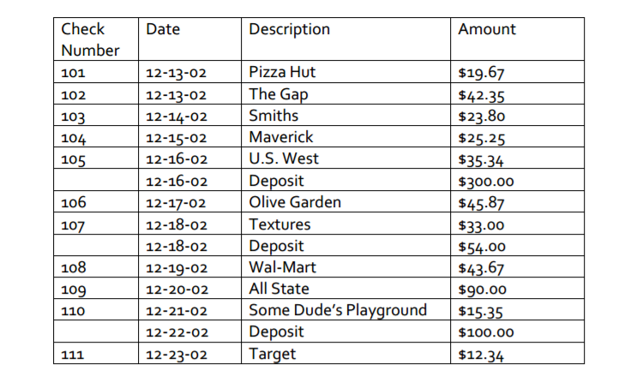

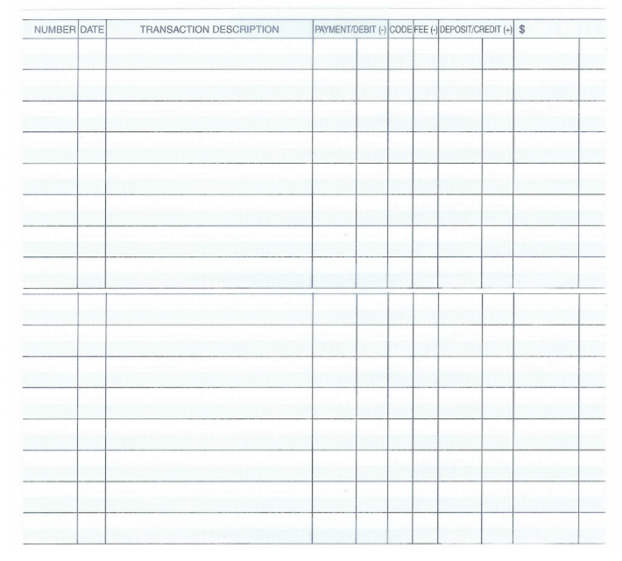

Choose a checking and deposit transactions from above and complete one check and one deposit slip.

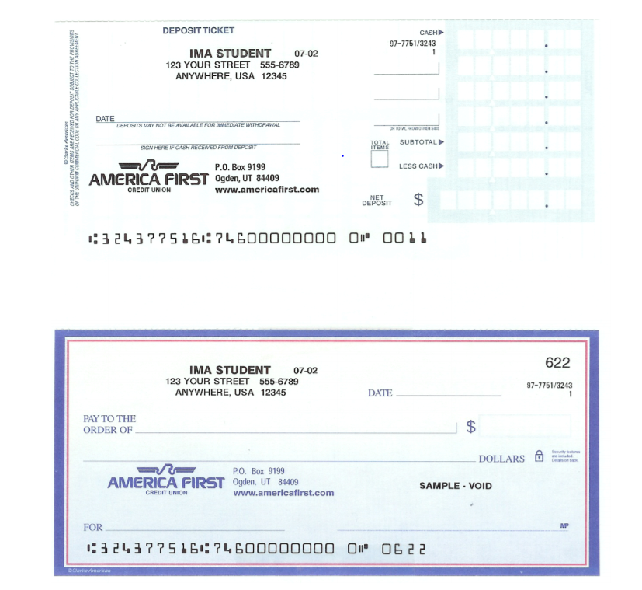

Check Your Understanding

1. What is the different between an **account balance** and a **minimum balance**?
2. Why is it a good idea to keep a **check register**?
3. If you were going to open a checking account today, which criteria or perks would be most important to you?